OSSP
Practical-Assignment1
Name: Haadi Hasil roll No.:2520030297
1.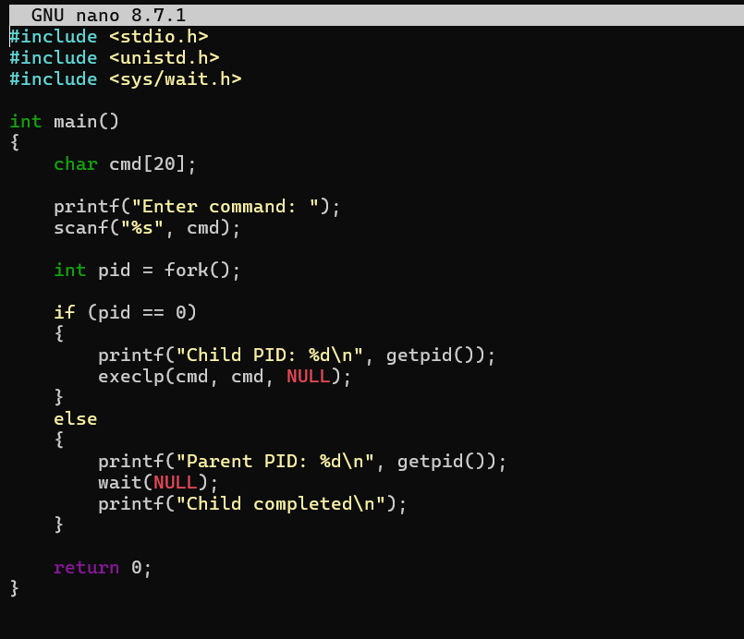
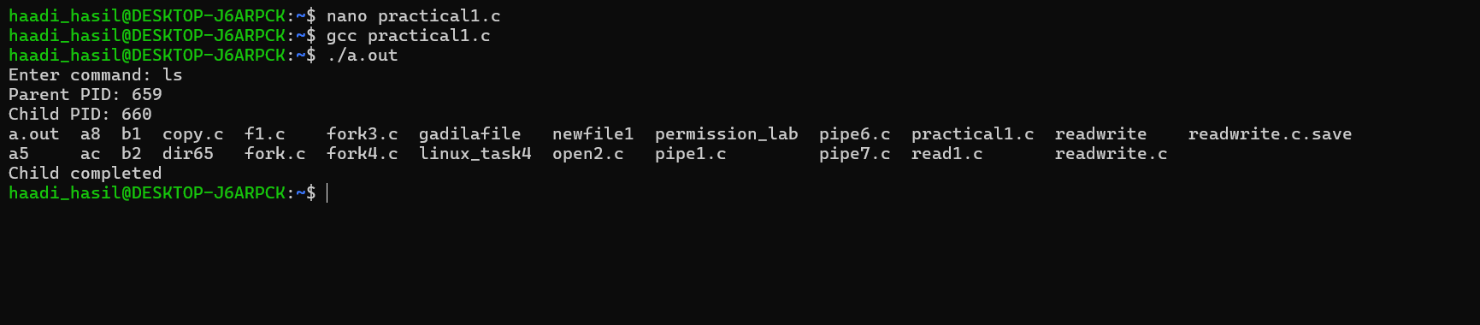
2. 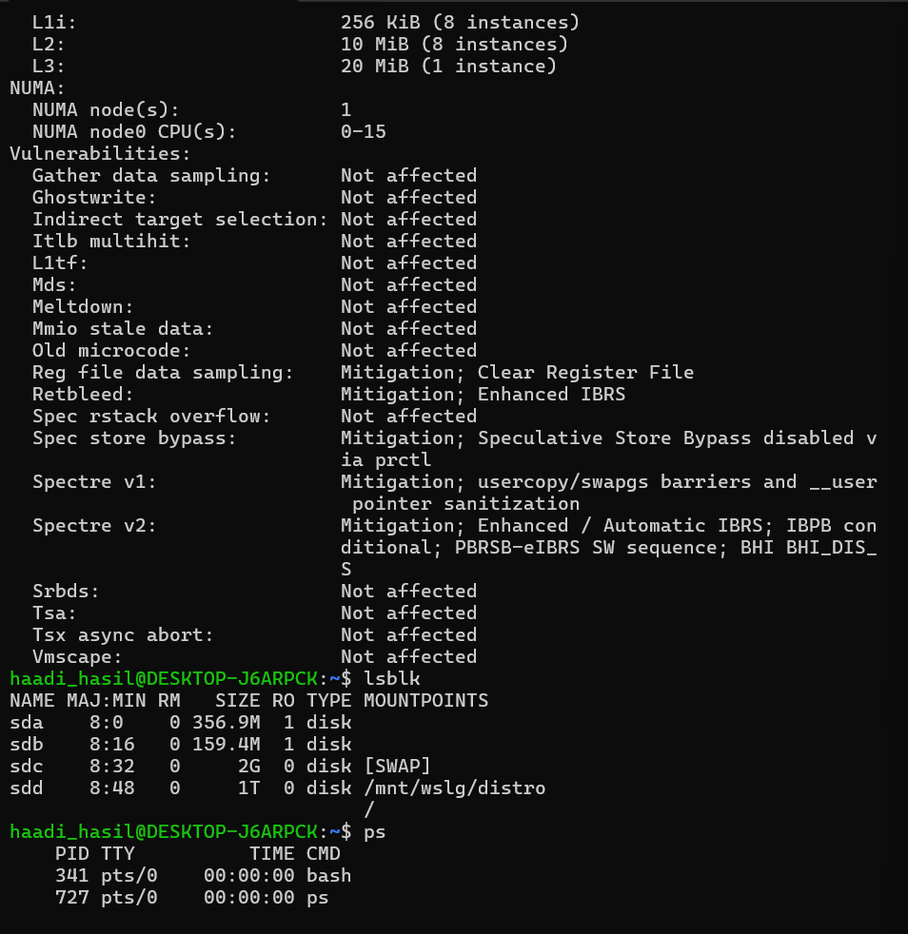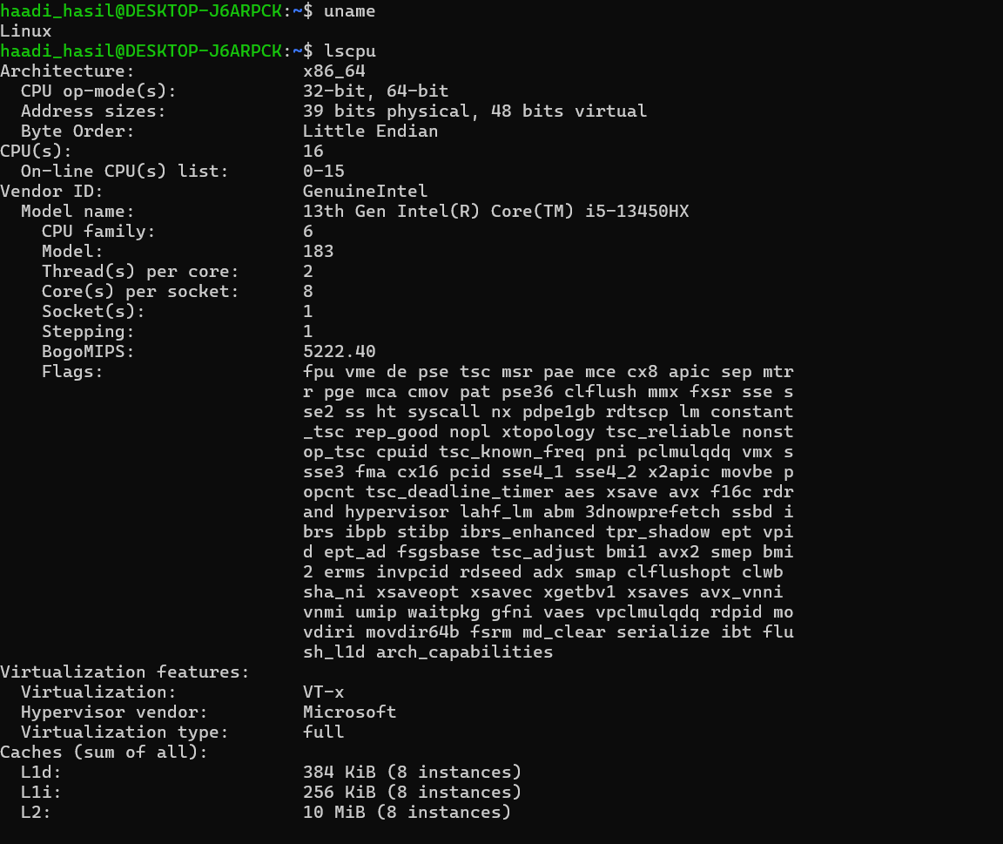
- Linux OS acts as a link between computer hardware and applications.
- Linux manages the CPU using process scheduling.
- Linux manages storage using files, directories, and file systems.
- uname is used to check the Linux kernel and system information.
- Iscpu gives details about the CPU, cores, threads, and architecture.
- Isblk shows the storage devices, disks, SSDs, and partitions.
- ps is used to see the running processes and their PIDs.
- top shows the real-time CPU, memory, and process usage.

